How light travels: Investigation method

Question: Does light travel in a straight line?
Aim: To determine if light travels in a straight line.

Materials:
- Blu-tack or plasticine
- 3 light shield cards
- 1 torch
- a thick book that can stand on its own
- a piece of string
- ruler
Method 1:
- Carefully fold each light shield card in half using the cross as a marker for the mid-point.
- Cut a small hole in the centre of each card where the lines cross.
- Stand the book on the desk.
- Place the cards in a straight line 10 cm apart. Use the Blu-tack or plasticine to help them stand up (see diagram below).
Check that the holes are lined up by looking through them

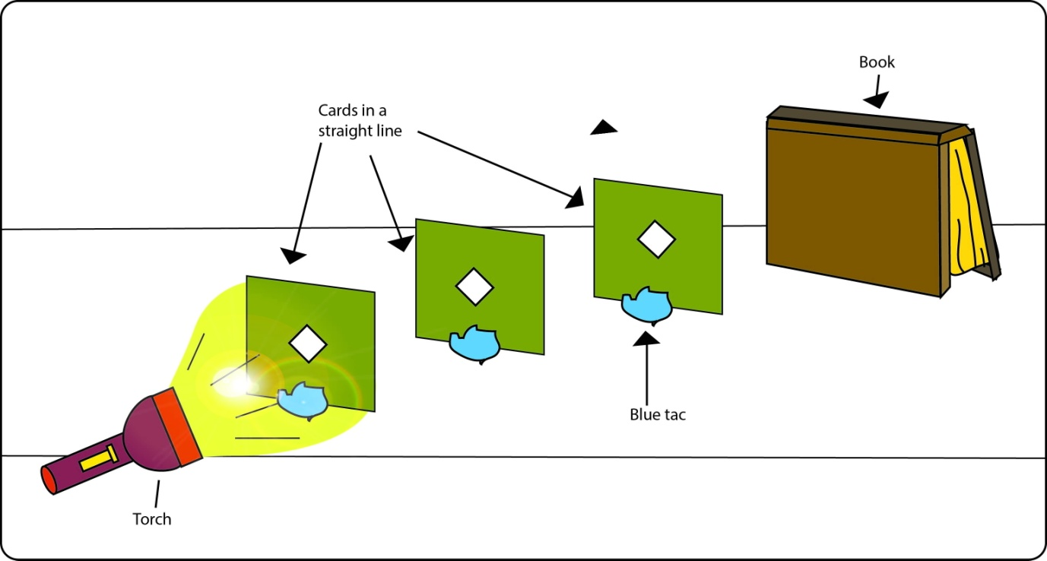
Predict (1) what will happen when you shine the light through the hole in the first card and the holes are lined up straight.

- Shine the torch through the hole in the first card.
- Record your observations.
- Thread the string carefully through the holes until it can’t go any further.
- Record your observations.
Method 2:
- Move the cards so that the holes are no longer in a straight line.
Predict (2) what will happen when you shine the light through the hole in the first card and the holes are not lined up straight.

- Shine the light through the first hole.
- Record your observations.
- Thread the string carefully through the first hole and then make it reach the book.
- Record your observations.

