How to make a periscope

Materials
- 1 sheet of cardboard
- Scissors
- Tape
- Pencil
- 2 small mirrors
- Ruler
- Adhesive putty

Method
1 Measure the width of your mirrors.
2 On your sheet of cardboard rule up four columns that are each the width of your mirror.
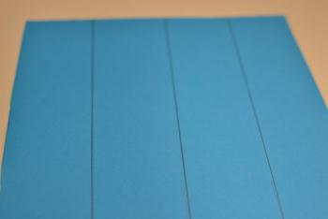
3 Fold along the lines so you have formed a box.
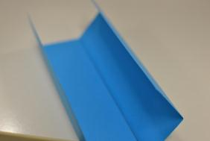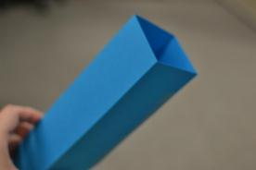
4 Tape the edges together

5 On one end of the box, cut a flap that is the same height as your mirror.
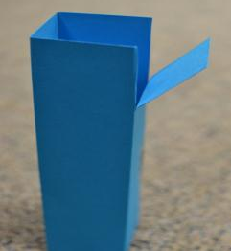
6 Stick a mirror to the inside of this flap with some blue tac

. 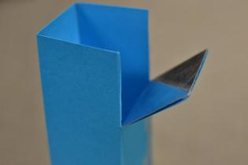

7 Cut another flap on the other end and on the opposite side.

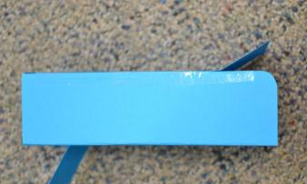
8 Stick the other mirror to the inside of this flap with some adhesive putty

Cut away the sides of the box opposite the mirrors on either end.

10 Bend the flaps inwards to try to find the correct angle so that what is reflected on the top mirror is also seen on the bottom mirror.
11 Draw a line to mark where the correct angles are on either end.
12 Cut off this bit of cardboard and tape it to the edge of the box.

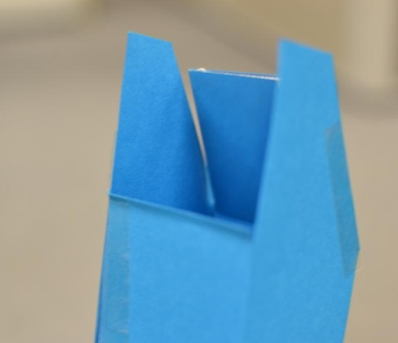
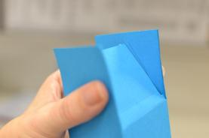

13 Look through the bottom hole to see over fences or even around corners.
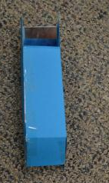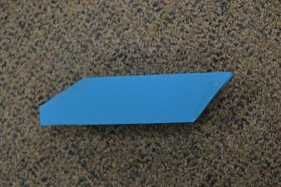
This is basically what the completed periscope should look like.

