How we see things: Teacher notes

In this lesson students look at how we see things through the reflection of light.

They will compare how a pinhole camera is similar to the human eye. The students will understand that light reflects off an object and enters our eyes to form an image.

If you would like more detailed information about how this happens, select from one of the following websites. The combination of the

- http://www.youtube.com/watch?v=8jkTBTDIhJ8
- http://www.curriculumbits.com/physics/how-does-a-pinhole-camera-work/
- These cameras provide a great opportunity to discuss how the light enters a small hole and forms an inverted image.
- http://www.childrensuniversity.manchester.ac.uk/interactives/science/brainandsenses/eye/
- This is a great kid friendly version of how the eye works

These two resources are great to tie in the thoughts of this lesson, they explain the theory of how a pin hole camera works with how the eye works .
- http://www.curriculumbits.com/physics/how-does-a-pinhole-camera-work/
This web site has an animation about how a pin hole camera works, it aligns with the video about how the eye works.

- http://www.childrensuniversity.manchester.ac.uk/interactives/science/brainandsenses/eye/
This is a great kid friendly version of how the eye works

Pinhole cameras

In this lesson you will need to provide at least one pinhole camera for the students to interact with. It would be ideal if the students could construct their own to deepen understanding.

There are a number of different versions of this device that can be made.
Below is a selection of websites that contain information on pinhole cameras (often referred to as camera obscuras) and how to construct them.

About light
- http://www.learner.org/teacherslab/science/light/
Go into Exploratorium for fantastic resources
Create a pinhole camera (Teach engineering)
- http://www.teachengineering.org/view_activity.php?url=collection/cub_/activities/cub_soundandlight/cub_soundandlight_lesson8_activity1.xml
- This uses a milk carton
Build a pinhole camera and explore the properties of light
- http://suite101.com/a/build-a-pinhole-camera-and-explore-the-properties-of-light-a324756
- This uses a larger box, such as a tea chest.
Make your own pinhole camera (CSIRO)
- http://www.csiro.au/files/files/p5rd.pdf
- This uses two boxes of the same size.
Pringles pinhole (Exploratorium)
I have made this website into a pdf
- http://www.exploratorium.edu/science_explorer/pringles_pinhole.html
- This uses cylinder shaped chip container

Peek boxes

In this lesson you will need to provide one peek box per group.

The ideal box to use is a shoebox; however, it is perfectly acceptable to use another box of a similar size, e.g. cereal box. These boxes should be kept as they will be used in the next lesson and can then be used again for the assessment item.

These are a great way to provide a dark environment. To begin with, the groups should be given a half complete box, i.e. a box with only one door cut out.

An object should be placed inside each box. It should be something that is small enough to fit in the box but big enough to be seen by the students (e.g. ball, small toy, stapler).

Guide students in their discussion so as to develop a solution that will allow a light source to illuminate the object.

The completed box should look something like the diagram below.

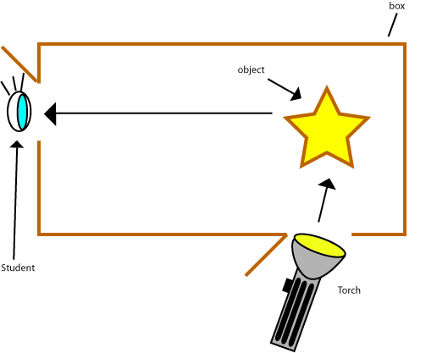

Some suggestions for students to explain their findings would be a diagram as pictured, or a flow chart.

Example:

